Provisional Application Draft

SYSTEM AND METHOD FOR ESTABLISHING PROVABLE ORIGINATION AND TEMPORAL CONTINUITY OF HUMAN THOUGHT USING CRYPTOGRAPHIC CUSTODIAL CHAINS

Based on Appendix A:
# R-0000000000000001— Proof-of-Thought™ Founding White Paper

Field of the Invention
The present invention relates generally to cryptographic recordkeeping, evidentiary custody systems, authorship verification, and intellectual property provenance. More particularly, it relates to systems and methods for cryptographically sealing, timestamping, chaining, and custodially preserving human-originated cognitive artifacts (“Thoughts”) in order to establish provable origination, temporal priority, continuity of ideation, and evidentiary integrity in both human-only and human–artificial intelligence creative environments.

Background of the Invention
Existing systems for establishing authorship, invention priority, and provenance rely on publication platforms, patent offices, notaries, institutional trust, or centralized digital services. These systems are slow, jurisdiction-bound, disclosure-forcing, and increasingly ineffective in the presence of generative artificial intelligence capable of producing synthetic artifacts at scale. There exists no neutral, privacy-preserving, cryptographically verifiable civilizational substrate for establishing provable origination and continuity of human thought itself. Accordingly, a need exists for a new technical infrastructure that enables secure sealing, custodial preservation, cryptographic chaining, and evidentiary verification of human cognitive origination without requiring public disclosure or reliance on any single institution.

Summary of the Invention

The invention provides systems, methods, and computer-readable media for implementing a Proof-of-Thought™ infrastructure comprising genesis records, append-only chained thought records, cryptographic hashing, timestamp attestation, custodial storage, and verifiable continuity of ideation. The system enables provable establishment of origination, temporal priority, custody, and lineage of human thought independent of publication, patent filing, or institutional trust. The invention further provides embodiments supporting intellectual property defense, trade secret continuity, research provenance, creative authorship verification, and AI–human origination distinction.
Detailed Description of the Embodiments

Overview
The following embodiments describe non-limiting example implementations of the Proof-of-Thought™ system, demonstrating how the constitutional, cryptographic, and evidentiary principles of the invention may be instantiated in real technical architectures. These embodiments are illustrative and do not limit the scope of the claims.

Embodiment 1 - Genesis Thought Sealing System
In one embodiment, a computing system receives a first digital submission representing a Genesis Thought. The submission may comprise text, images, audio, diagrams, structured data, software code, or combinations thereof.
The system performs:
- Canonicalization of the submission into a deterministic byte sequence;
- Cryptographic hashing of the canonical bytes to produce a Genesis hash;
- Acquisition of one or more trusted timestamp attestations bound to the Genesis hash;
- Creation of a custody bundle comprising the canonical data, Genesis hash, timestamp attestations, and metadata;
- Placement of the custody bundle into immutable custodial storage.
The system then issues a cryptographic receipt to the author, containing at least the Genesis hash, timestamp attestation, and custody verification reference.
This Genesis Thought establishes the root of a Thought chain.

Embodiment 2 - Chained Thought Continuation
In another embodiment, a user submits a subsequent Thought intended to extend an existing chain.
The system:
- Canonicalizes the subsequent Thought;
- Computes a chained hash incorporating the predecessor Thought’s hash;
- Obtains a new timestamp attestation;
- Generates a new custody bundle;
- Stores the new bundle immutably.
The resulting chained Thought cryptographically proves chronological continuity of ideation.

Embodiment 3 - Thought Receipt and Evidentiary Certificate Generation
In an embodiment, the system generates a human-readable evidentiary certificate for any sealed Thought.
The certificate may include:
• Cryptographic hash
• Timestamp attestations
• Chain identifier
• Custody verification reference
• Human-readable formatting
The certificate may be rendered digitally (PDF) or physically (printed, engraved, etched, laser-marked, or embossed).
Any alteration of the underlying Thought invalidates the certificate.

Embodiment 4 - Machine-Engraved Seal Generation
In an embodiment, the system dynamically engraves a tamper-evident visual or physical seal containing:
• Cryptographic hash
• Timestamp
• Chain identifier
• Custody verification reference
The seal is algorithmically derived from the Thought such that it becomes cryptographically invalid upon Thought modification.
This sea may be applied to digital PDFs, printed certificates, engraved plates, plaques, packaging, artwork, or archival storage media.

Embodiment 5 - Selective Disclosure and Verification
In an embodiment, authors are issued private cryptographic control references enabling:
• Verification of Thought existence
• Controlled disclosure of Thought content
• Controlled extension of Thought chains
• Succession and inheritance management
Custodians cannot disclose Thought content without cryptographic authorization.

Embodiment 6 - Multi-Custodian Redundancy
In an embodiment, custody bundles are redundantly stored across multiple custodial authorities. Each custodian independently preserves sealed Thoughts while cryptographically verifying consistency across custodians.
This creates jurisdiction-resilient evidentiary permanence.

Embodiment 7 - Human–AI Origination Boundary
In an embodiment, the system enforces a human-origin anchoring requirement such that sealed Thoughts must originate from authenticated human authorship contexts, even when AI-assisted generation is present.
This preserves human origination integrity.

Embodiment 8 - Long-Horizon Intellectual Legacy Chains
In an embodiment, Thought chains may persist across decades, generations, or organizations, supporting inheritance, escrow, archival custody, and civilizational knowledge preservation.

Embodiment 9 - Jurisdictional Evidentiary Interfaces
In an embodiment, Proof-of-Thought records may be exported into jurisdiction-specific evidentiary formats compatible with courts, patent offices, regulatory agencies, and legal discovery systems while preserving cryptographic integrity.

Embodiment 10 - Private Economic and Licensing Layers
In an embodiment, commercial licensing, escrow, brokerage, disclosure notarization, and monetization layers may be built atop Proof-of-Thought while remaining constitutionally subordinate to custodial neutrality and author sovereignty.

Brief description of the drawings

FIG. 1 is a system architecture diagram illustrating an exemplary Proof-of-Thought™ platform, showing an author device in communication with a processing system that includes canonicalization, hashing and chaining, timestamp attestation, custody, control, and verification modules configured to seal, preserve, and verify human-originated Thoughts under immutable custodial authority.

FIG. 2 is a flow diagram illustrating an exemplary method for sealing a Genesis Thought, including canonicalization of an original human cognitive artifact, cryptographic hash generation, trusted timestamp attestation, custody bundle creation, and placement of the Genesis Thought into immutable custodial storage with issuance of a cryptographic receipt.

FIG. 3 is a schematic diagram illustrating an append-only cryptographic Thought chain in which each subsequent Thought is mathematically bound to a predecessor Thought by incorporation of predecessor hash values, thereby establishing irreversible continuity and provable chronological ordering of human cognitive events.

FIG. 4 is a custody topology diagram illustrating redundant multi-custodian preservation of sealed Thoughts across multiple independent custodial authorities to provide jurisdiction-resilient evidentiary permanence and cryptographic integrity.

FIG. 5 is a schematic diagram illustrating generation of a human-readable evidentiary certificate and machine-engraved seal derived from sealed Thought data, including cryptographic hashes, timestamp attestations, chain identifiers, and custody verification references configured to invalidate upon alteration of the underlying Thought.

FIG. 6 is a schematic diagram illustrating selective disclosure and verification of sealed Thoughts, showing cryptographic control references enabling verification of Thought existence, controlled disclosure of Thought content, and retrieval of custody-bound verification data.

FIG. 7 is a conceptual diagram illustrating the Genesis–Thought continuum, depicting a time-indexed sequence of chained human cognitive events representing the evolutionary progression of an idea across successive sealed Thoughts.
Claims
- A computer-implemented method for establishing provable origination of human Thought (human cognitive activity), comprising: receiving, by a processing system, a first digital artifact representing an original human cognitive event (Thought); transforming the first digital artifact into a deterministic canonical byte representation; generating a first cryptographic hash value from the canonical byte representation; obtaining a trusted timestamp attestation bound to the first cryptographic hash value; and storing the first digital artifact and the first cryptographic hash value in an immutable custodial storage system such that subsequent alteration of the first digital artifact is cryptographically detectable.
- The method of claim 1, further comprising issuing to an originating human author a cryptographic receipt comprising the first cryptographic hash value and the trusted timestamp attestation, the cryptographic receipt constituting evidence of temporal priority of the original human cognitive event.
- The method of claim 1, further comprising receiving a subsequent digital artifact representing an additional human cognitive event, transforming the subsequent digital artifact into a subsequent canonical byte representation, generating a subsequent cryptographic hash value from the subsequent canonical byte representation and the first cryptographic hash value, and storing the subsequent digital artifact and the subsequent cryptographic hash value in the immutable custodial storage system to form an append-only cryptographic chain of human cognition.
- The method of claim 3, wherein the subsequent digital artifact represents a refinement, elaboration, analysis, design evolution, creative development, or inventive progression related to the original human cognitive event.
- A system for evidentiary custody of human cognitive artifacts, comprising: at least one processor; a canonicalization module configured to generate deterministic canonical byte representations of submitted digital artifacts; a hashing and chaining module configured to generate cryptographic hash values incorporating predecessor hash values; a timestamp attestation interface configured to bind trusted timestamp attestations to cryptographic hash values; and an immutable custodial storage subsystem configured to preserve digital artifacts and associated cryptographic records in a non-modifiable manner.
- The system of claim 5, wherein the custodial storage subsystem is constitutionally restricted from monetizing, mining, training on, altering, or deriving secondary value from preserved digital artifacts.
- A non-transitory computer-readable medium storing instructions that, when executed by at least one processor, cause the at least one processor to perform the method of any of claims 1 through 4.
- The method of claim 1, wherein the first digital artifact comprises text, image data, audio data, structured data, software code, three-dimensional model data, or any combination thereof.
- The method of claim 3, wherein the append-only cryptographic chain establishes provable temporal ordering and immutable continuity of ideation across a plurality of human cognitive events.
- The system of claim 5, wherein selective disclosure of preserved digital artifacts is exclusively controlled by an originating human author through cryptographic authorization mechanisms.
- The method of claim 1, further comprising generating a visual or physical certificate seal containing machine-engraved indicia including at least the cryptographic hash value, timestamp attestation, and chain identifier, wherein the indicia are dynamically engraved based on the sealed Thought data to produce a tamper-evident human-readable certificate of custody.
- The method of claim 3, wherein each subsequent Thought further comprises an independent timestamp attestation, thereby establishing a time-indexed evolution of ideation that evidences chronological development of a chain of human cognitive events.
- A method of generating a human-readable evidentiary certificate for a sealed human Thought, comprising: dynamically engraving, by a processing system, onto a visual or physical certificate seal, machine-generated indicia comprising at least: (a) a cryptographic hash of the sealed Thought, (b) a trusted timestamp attestation, (c) a chain identifier, and (d) a custody verification reference, wherein said indicia are algorithmically derived from the sealed Thought such that alteration of the Thought invalidates the certificate.
- The method of claim 3, wherein the chain of Thoughts constitutes a time-indexed evidentiary model of cognitive evolution, establishing provable chronological development of human ideation independent of artifact publication.

Figures
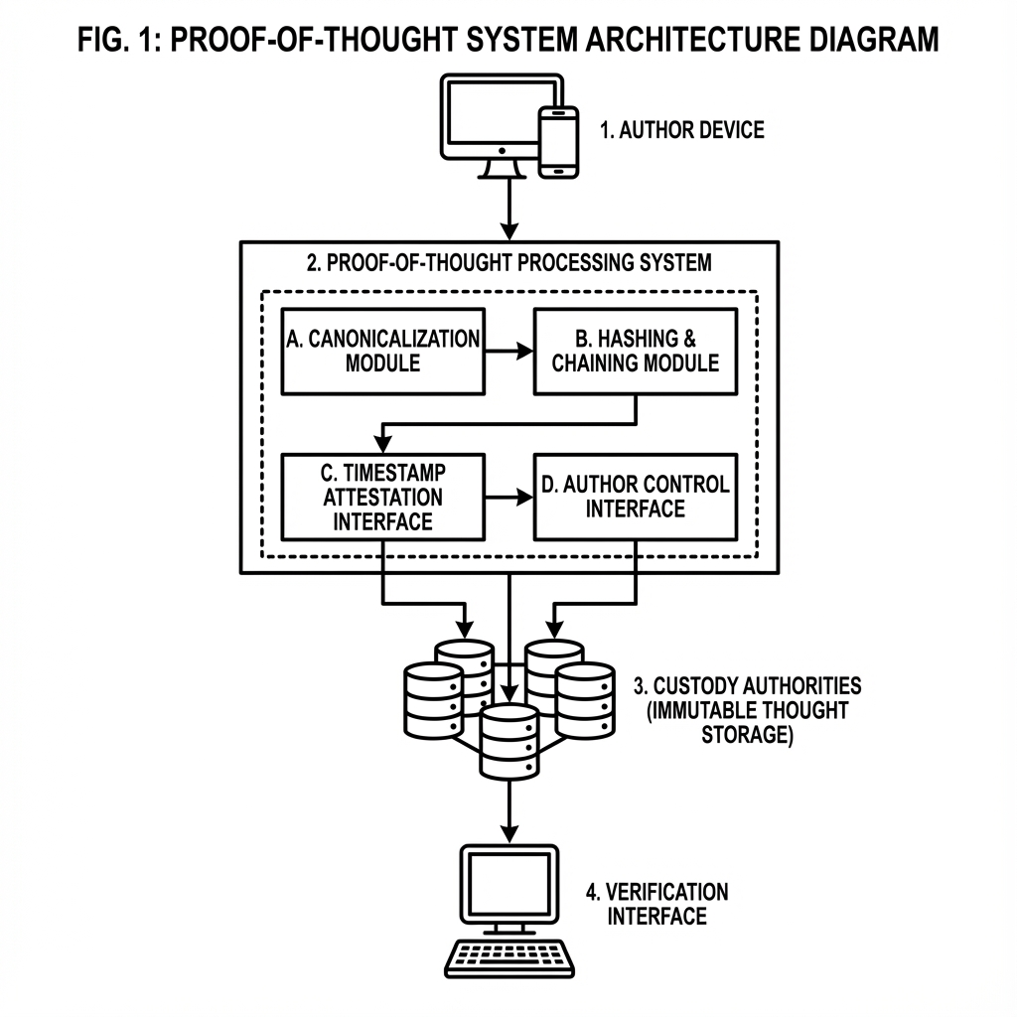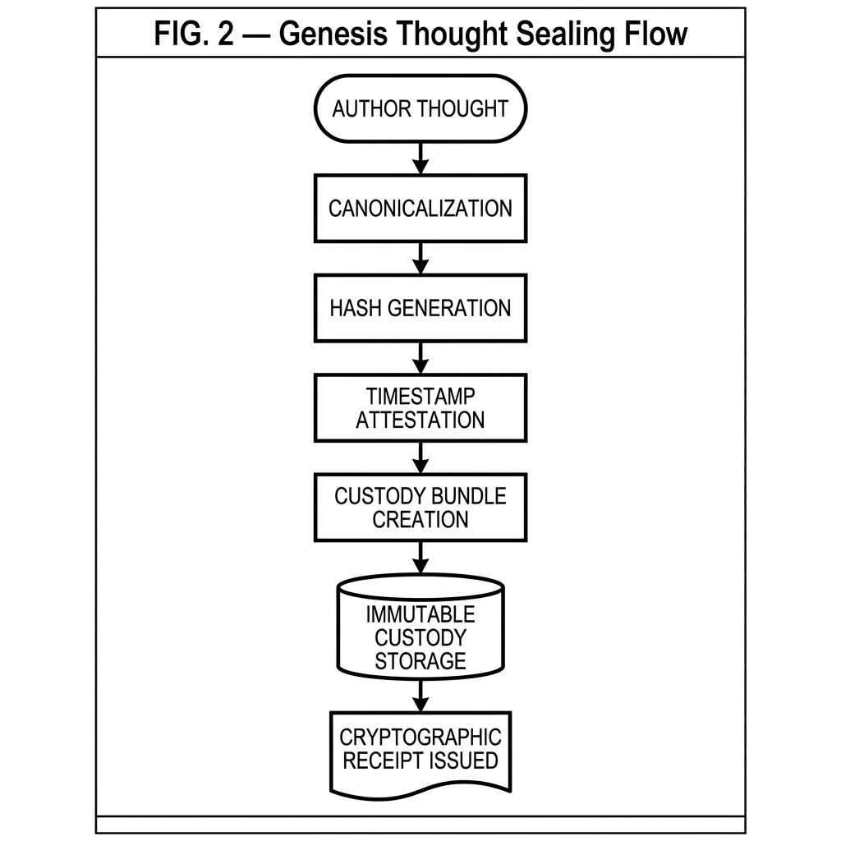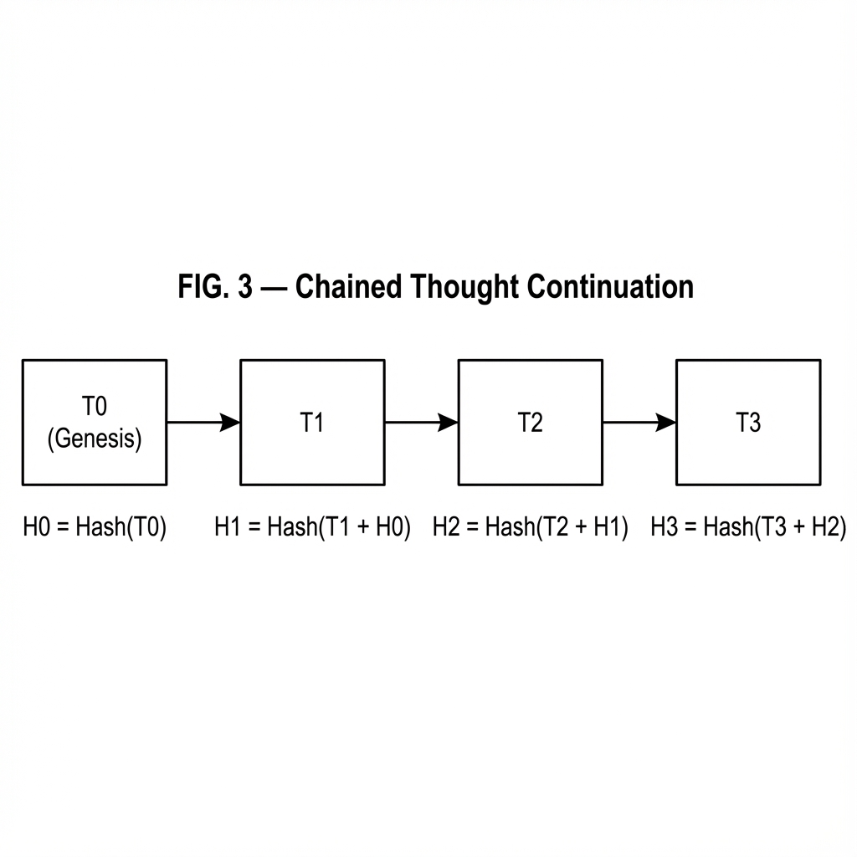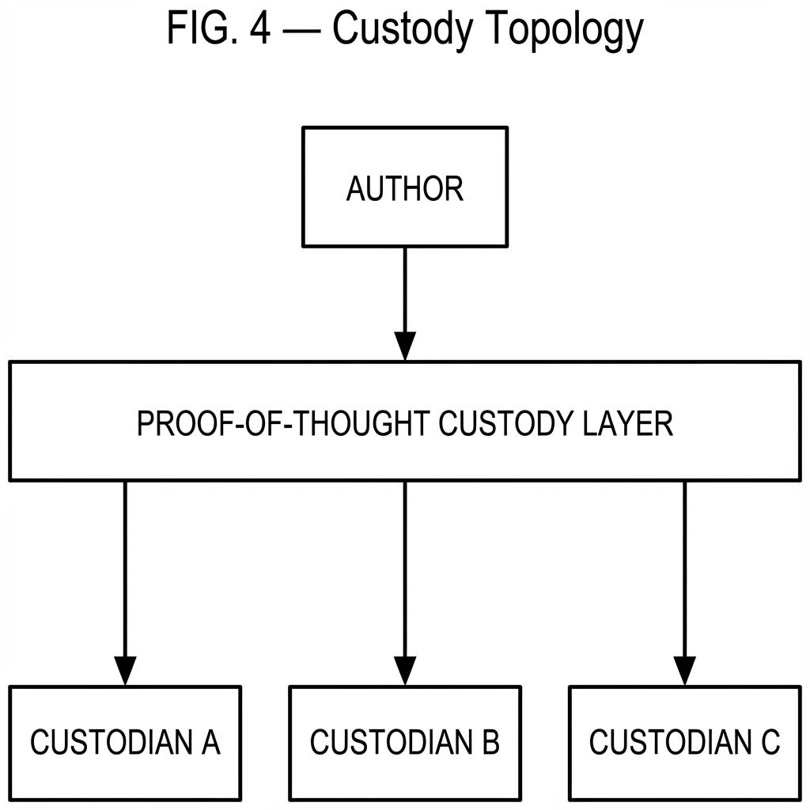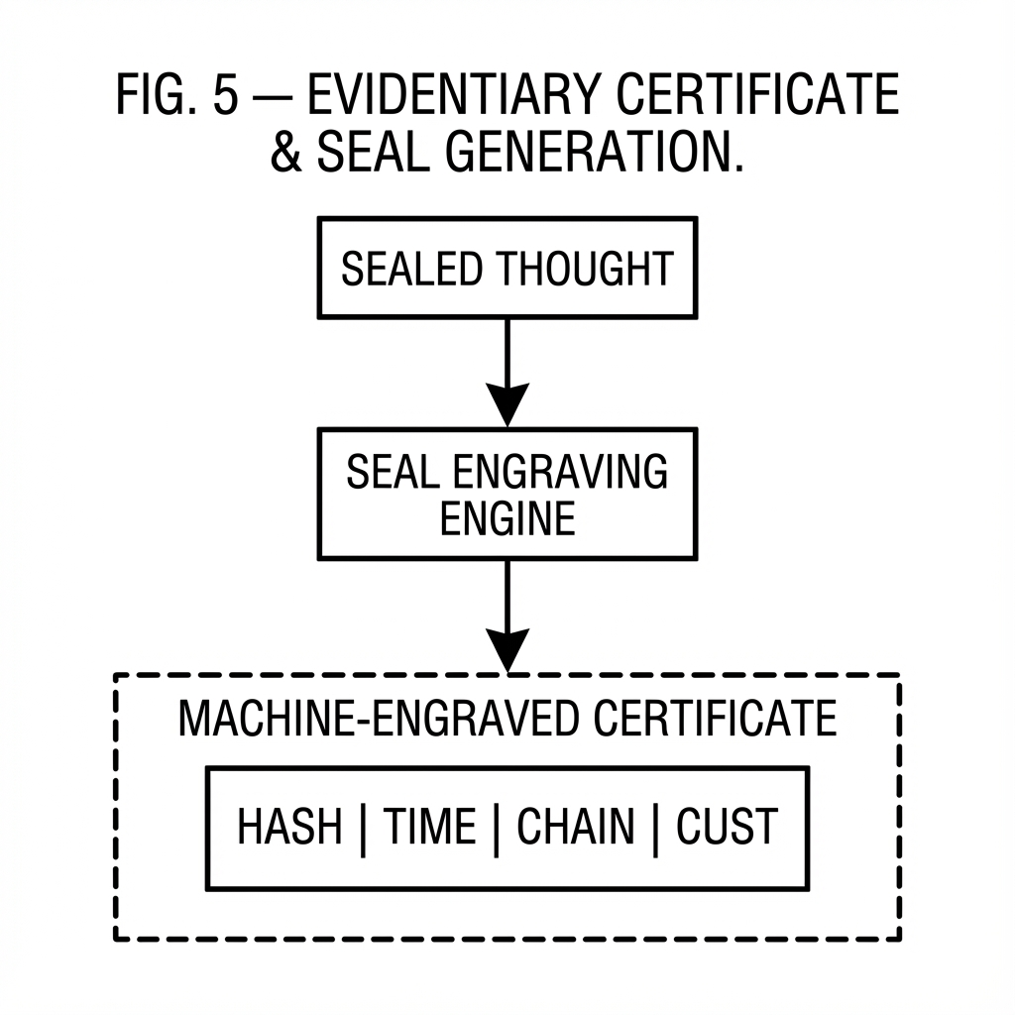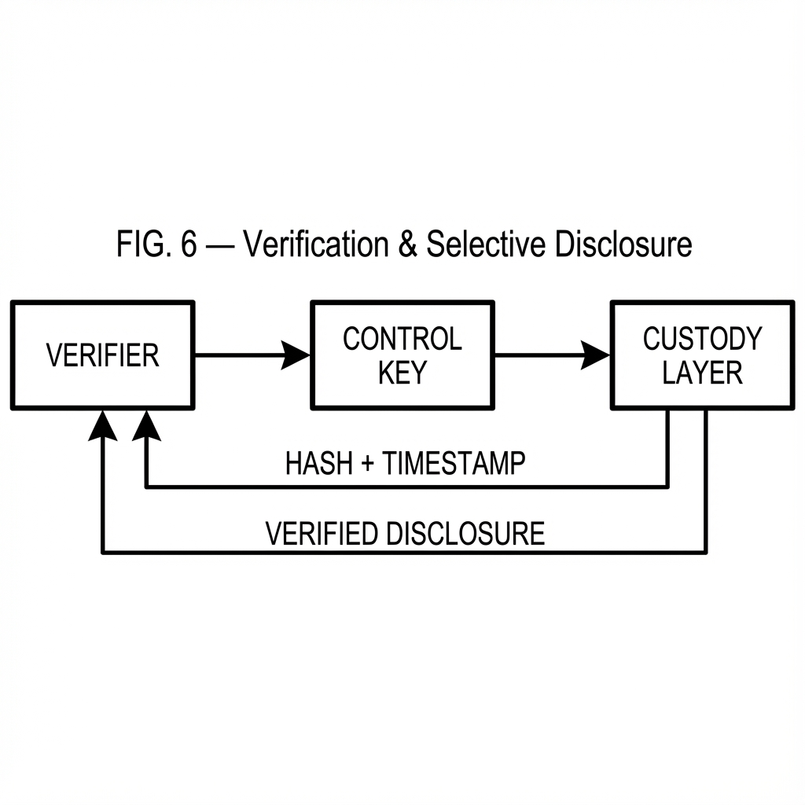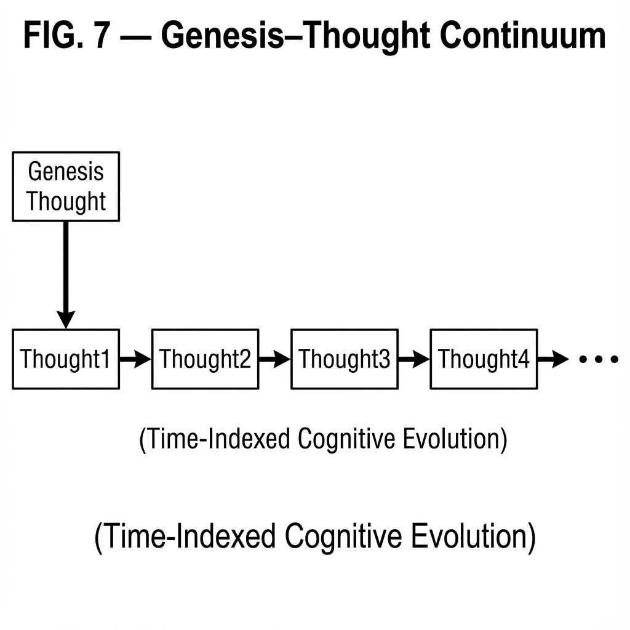

Appendix A
# R-0000000000000001 - Proof‑of‑Thought™ Founding White Paper

## Master Outline Master Outline
- Executive Abstract
- Historical Context & The Problem of Original Thought
- Philosophical Foundation (Human Originality in the AI Era)
- System Overview
- Cryptographic Architecture
- Mathematical Formalization of Proof-of-Thought
- Chain Semantics (Genesis–Thought Continuum)
- Custody, Immutability & Evidentiary Model
- Governance & Constitution Layer
- Legal & IP Implications
- Use-Case Archetypes
- Ethical Safeguards
- Future Evolution
- Conclusion

1. Executive Abstract

Proof-of-Thought™ is a cryptographic, custodial, and evidentiary infrastructure designed to establish provable human authorship, temporal priority, and chain-of-idea continuity in an era where artificial intelligence increasingly participates in the generation of knowledge, invention, art, and strategy. It provides individuals and organizations with a mathematically verifiable mechanism to timestamp, preserve, and evolve original thought while maintaining continuity of authorship and immutability of record.

At its core, Proof-of-Thought introduces a new primitive for civilizational recordkeeping: the *Genesis Thought* - the first recorded crystallization of a concept - and an append-only chain of subsequent Thoughts that document the living evolution of that concept through sketches, revisions, data, imagery, and formalizations. Each Thought is independently sealed, cryptographically chained, and preserved under third-party custody, forming a continuous, tamper-evident ledger of intellectual emergence.

Proof-of-Thought is not a publishing platform, a patent registry, nor a content hosting service. It is an evidentiary substrate - a neutral and durable layer that enables provable possession, temporal precedence, and continuity of creative lineage without requiring public disclosure. In doing so, it creates a new class of civil, legal, and economic primitives for protecting originality, coordinating collaboration, and asserting authorship in both human-only and human-AI hybrid creative environments.

As artificial systems become increasingly capable of producing plausible inventions, artworks, strategies, and scientific hypotheses, Proof-of-Thought establishes a durable anchor for human-originated intent and authorship - ensuring that original human thought remains distinguishable, preservable, and legally meaningful in the decades to come.

2. Historical Context & The Problem of Original Thought

Throughout human history, original thought has been the rarest and most valuable human output. Civilizations have risen and fallen on the strength of ideas—mathematical discoveries, philosophical doctrines, engineering breakthroughs, artistic movements, and scientific theories. Yet until the digital age, there existed no universal, neutral, and tamper-proof way to prove when a thought was conceived, who conceived it, and what exactly the original form of that thought was.
Historically, society relied on physical artifacts and institutional trust as imperfect substitutes for proof of origination. Manuscripts, sealed envelopes, laboratory notebooks, signed napkins, notarized letters, patent filings, and witness testimonies attempted to establish priority of invention or authorship. These mechanisms were slow, jurisdiction-bound, expensive, and fragile. They failed across borders, failed across time, and failed at scale.
The digital era amplified both creation and ambiguity. While ideas could now be produced, shared, and modified at unprecedented speed, the ability to prove authentic origination collapsed. Files could be duplicated perfectly, timestamps could be manipulated, authorship could be spoofed, and custody could not be independently verified without relying on centralized platforms whose incentives were misaligned with historical truth.
The arrival of generative artificial intelligence has further destabilized the epistemic ground. Machines can now synthesize text, code, designs, images, music, and research artifacts at superhuman scale. In such an environment, mere possession of a digital artifact no longer implies authorship. Timestamped uploads no longer imply origination. Content itself no longer proves cognition.
Society is entering an era where original human thought risks becoming indistinguishable from synthetic production unless a new foundational layer of proof is introduced.
Proof-of-Thought™ emerges as a response to this civilizational inflection point: a cryptographically anchored, custody-preserving, mathematically verifiable substrate for establishing human origination, temporal priority, and immutable intellectual lineage - independent of publication, patents, or institutional trust.

3. Philosophical Foundation (Human Originality in the AI Era)
Human civilization is not built on information alone; it is built on intention, consciousness, and the act of original conception. A scientific paper, a poem, a theorem, or a design drawing is not merely data - it is the crystallization of an internal cognitive event: a moment in which a human mind formed a new structure of meaning that did not previously exist.
For millennia, society implicitly assumed that such moments were self-authenticating. If an artifact existed, it was presumed that a human must have conceived it. That assumption has now collapsed.
In the age of generative artificial intelligence, outputs no longer guarantee cognition. Machines can emit artifacts without experiencing insight, intention, or comprehension. As a result, content is no longer evidence of thought.
Proof-of-Thought™ is grounded in a philosophical distinction that becomes critical in this new era:
• Thought is a human cognitive event.
• Artifacts are merely its external shadows.
The system does not attempt to prove that a human is "better" than a machine, nor that machine outputs are invalid. Instead, it introduces a neutral civilizational primitive that allows humans to cryptographically assert and preserve moments of original cognition - independent of the artifacts those moments may later produce.
A Proof-of-Thought record therefore represents more than a timestamped file. It represents an ontological claim:
At a specific moment in time, a specific human consciousness possessed a specific structure of original intent and meaning.
This philosophical foundation is what differentiates Proof-of-Thought from blockchains, version control systems, registries, or publication platforms. Those systems track changes to data. Proof-of-Thought tracks the emergence of thought itself.
By creating an append-only chain of Thoughts anchored to a Genesis Thought, the system models ideation as a living, evolving cognitive lineage rather than as static documents. It preserves not just what was written, but that it was thought, when it was thought, and how the thought evolved - forming a new civilizational memory layer for human originality.

4. System Overview
Proof-of-Thought™ is implemented as a layered evidentiary protocol composed of three primary primitives: the Genesis Thought, the Thought Chain, and the Custody Layer.
The Genesis Thought represents the first sealed crystallization of an idea. It anchors the chain, defines authorship origin, and establishes temporal priority. Every subsequent Thought - whether a sketch, revision, dataset, diagram, or formal document - is appended as a cryptographically chained successor.
Each Thought is independently sealed, hashed, timestamped, and preserved under neutral third-party custody. The system does not require public disclosure; it only requires mathematical verifiability. Custody records ensure that the sealed artifacts cannot be altered, removed, or substituted without detection.
The architecture separates creation, custody, verification, and disclosure into independent layers, ensuring that authorship proof remains durable even if platforms, companies, or governments change. This separation allows Proof-of-Thought to function as a neutral civilizational substrate rather than a proprietary application.
At a high level, the system operates as follows:
• A human submits an original Thought (text, image, or other digital expression). • The Thought is normalized, hashed, timestamped, and sealed. • A custody authority preserves the sealed artifact immutably. • A cryptographic receipt is issued to the author. • Subsequent Thoughts may be appended, forming an immutable chain of ideation.
The result is a mathematically verifiable, temporally ordered lineage of human thought - preserved without requiring public exposure, and verifiable without reliance on institutional trust.

5. Cryptographic Architecture
The cryptographic architecture of Proof-of-Thought™ is designed to establish three guarantees simultaneously: immutability, temporal priority, and lineage continuity - without requiring public disclosure or reliance on any single institutional authority.
At the core of the system is a deterministic canonicalization and hashing pipeline. Every submitted Thought is first normalized into a canonical byte representation. This process removes ambiguities in encoding, whitespace, and metadata ordering, ensuring that identical intellectual content always produces an identical cryptographic fingerprint.
A secure cryptographic hash (SHA-256) is then computed over the canonical representation. This hash becomes the immutable identifier of that Thought. Any alteration - even by a single bit - produces a completely different fingerprint, making tampering mathematically detectable.
A Genesis Thought is the foundational crystallization of an idea - the first sealed expression that establishes authorship origin and temporal priority for an intellectual lineage. It does not incorporate any predecessor and serves as the absolute root of a Proof-of-Thought chain.
Each non-Genesis Thought also incorporates the hash of its immediate predecessor, forming a cryptographic chain. This chaining mechanism establishes an irreversible sequence of ideation: later Thoughts cannot exist without proving the exact state of earlier Thoughts. The result is a tamper-evident cognitive lineage rather than a mere file history.
To establish temporal priority, each sealed Thought is timestamped and anchored to independent time-source attestations. These attestations are embedded into the receipt record and cryptographically bound to the Thought hash, preventing post-facto backdating or reordering.
Together, these mechanisms provide three civilizational guarantees:
• Immutability - sealed Thoughts cannot be altered without detection. • Priority - the first appearance of a Thought is mathematically provable in time. • Continuity - the evolution of an idea forms an irreversible cryptographic lineage.
This cryptographic foundation allows Proof-of-Thought to function as a universal evidentiary substrate - capable of proving origination, precedence, and ideation continuity independent of publication systems, legal jurisdictions, or institutional trust.

6. Mathematical Formalization of Proof-of-Thought
At its mathematical core, Proof-of-Thought™ models ideation as a directed acyclic cryptographic sequence over a canonical content space.
Let T₀ denote a Genesis Thought, and Tₙ denote the n-th subsequent Thought in a chain. Each Thought is represented as a canonical byte string Cₙ, produced by a deterministic normalization function N(·) over the submitted intellectual content.
A cryptographic digest is computed:
Hₙ = SHA-256( Cₙ ∥ Hₙ₋₁ ∥ Mₙ )
Where: • Cₙ is the canonicalized content of the Thought • Hₙ₋₁ is the predecessor hash (null for Genesis) • Mₙ is a metadata vector containing timestamp attestations and custody anchors
The inclusion of Hₙ₋₁ establishes irreversible lineage binding. Any mutation in any prior Thought invalidates all subsequent hashes.
A Proof-of-Thought chain therefore forms a strictly ordered cryptographic sequence:
T₀ → T₁ → T₂ → … → Tₙ
Such that:
∀ i < j : Hᵢ ≠ Hⱼ
And no element Tⱼ can exist without mathematically proving the exact state of all preceding Thoughts.
This construction guarantees: • Monotonic temporal ordering • Irreversible ideation lineage • Immutable authorship anchoring
Unlike blockchains, Proof-of-Thought does not require distributed consensus, tokens, mining, or public broadcast. Its mathematical objective is not economic agreement - it is civilizational truth: the provable continuity of original human cognition across time.

7. Chain Semantics (Genesis–Thought Continuum)
A Proof-of-Thought chain models ideation not as a hierarchy of “primary” and “secondary” documents, but as a living cognitive continuum. Every chain begins with a Genesis Thought - the first sealed crystallization of an idea - and extends through an ordered sequence of subsequent Thoughts that record how that idea evolves over time.
The Genesis Thought is ontologically unique: it has no predecessor, establishes authorship origin, and anchors temporal priority for the entire lineage. All subsequent Thoughts are cryptographically bound to this origin and to one another, forming an irreversible ideation sequence.
Importantly, the system makes no semantic assumption that later Thoughts are lesser, derivative, or subordinate. A subsequent Thought may represent a minor revision, a supporting sketch, a data set, a full scientific theory, a new invention, or even a conceptual breakthrough larger than the original Genesis Thought. The chain records continuity of cognition - not intellectual hierarchy.
Each appended Thought therefore represents a new sealed moment of human cognition that both: • Preserves the historical continuity of the idea • May itself constitute an independent creative, scientific, or legal milestone
This Genesis–Thought continuum allows Proof-of-Thought to capture the true nature of human ideation: non-linear, iterative, exploratory, and evolutionary. It preserves not merely documents, but the unfolding path of understanding, discovery, and invention as it actually occurs in the human mind.

8. Custody, Immutability & Evidentiary Model
Proof-of-Thought™ is not merely a cryptographic protocol; it is a custodial and evidentiary system designed to withstand legal, technological, and institutional change. Its purpose is not only to hash data, but to preserve provable intellectual existence across decades.
Each sealed Thought is placed under independent third-party custody. Custodians maintain immutable storage, redundancy, and auditability of sealed artifacts. Authors retain private control links that allow them to retrieve, verify, and extend their chains, while custodians remain unable to alter content without cryptographic detection.
Every Proof-of-Thought record therefore constitutes a complete evidentiary bundle: • Canonicalized content • Cryptographic lineage hashes • Timestamp attestations • Custodial preservation anchors
This bundle can be presented in legal, academic, commercial, or civil contexts as mathematically verifiable evidence of possession, authorship priority, and continuity of ideation - without revealing the content publicly unless the author chooses to disclose it.
In effect, Proof-of-Thought establishes a new class of civil evidence: immutable cognitive custody. It provides a durable bridge between cryptography and law, ensuring that original human thought remains provable, preservable, and defensible even as the nature of creation itself evolves.

9. Governance & Constitution Layer
Proof-of-Thought™ is governed not merely by code, but by an explicit constitutional layer that defines the civilizational rules of authorship, custody, continuity, and evidentiary integrity.
At the heart of this layer is the Proof-of-Thought Constitution - a normative framework that establishes: • What constitutes a valid Genesis Thought • The rights and responsibilities of authors • The obligations and limitations of custodial authorities • The conditions under which verification, disclosure, and succession may occur
This constitutional layer ensures that Proof-of-Thought is not reducible to any single company, platform, or jurisdiction. It defines the system as a public-interest civilizational substrate whose constitutional rules persist even if implementations change, while still allowing compliant commercial implementations, licensing, and service layers to be built on top of it.
Key constitutional principles include:
Authorial Sovereignty - Only the originating author controls disclosure, continuation, and succession of a Thought chain.
Custodial Neutrality - Custodians preserve, but do not interpret, alter, monetize, or censor Thought records.
Non-Disclosure by Default - Proof does not require publication. Privacy and secrecy are first-class civil rights.
Continuity of Lineage - Once a Thought chain exists, its historical continuity cannot be broken, erased, or rewritten.
Succession & Inheritance - Authors may constitutionally define how their chains may be transferred, inherited, or archived.
This governance layer transforms Proof-of-Thought from a technical system into a civil institution - one capable of preserving human originality as a protected class of historical and legal reality rather than a mere software feature.

10. Legal & IP Implications
Proof-of-Thought™ introduces a new evidentiary class for intellectual property, distinct from traditional copyright, trade secret, and patent systems. It does not replace existing IP regimes; rather, it provides a cryptographic and custodial foundation upon which legal rights may be asserted, defended, and negotiated.
A Proof-of-Thought record constitutes prima facie evidence of temporal priority, possession, and continuity of ideation. It may be used to support: • Patent priority claims • Trade-secret existence and continuity • Copyright authorship attribution • Contractual provenance verification • R&D audit trails and regulatory compliance
Because Proof-of-Thought operates without requiring public disclosure, it uniquely preserves patentability while still establishing early priority - resolving a long-standing tension between secrecy and proof.
Commercial implementations may layer services such as licensing, brokerage, escrow, disclosure notarization, and succession management atop the constitutional substrate. In doing so, Proof-of-Thought becomes not merely a defensive technology, but an enabling infrastructure for the lawful commercialization of human originality.
In effect, it creates a new legal primitive: provable possession of thought itself - a civil right that persists even as creative labor becomes increasingly automated.

11. Use-Case Archetypes
Proof-of-Thought™ is designed as a universal civilizational substrate rather than a single-domain product. Its primitives apply wherever original human cognition, creative priority, and intellectual lineage must be preserved under conditions of uncertainty, automation, and dispute. The following archetypes illustrate representative classes of use.
Scientific Discovery & Research Lineage - Researchers may seal early hypotheses, experimental designs, datasets, and interpretive breakthroughs as chained Thoughts. This creates provable priority of discovery, preserves unpublished negative results, and establishes immutable research provenance independent of journals, grants, or institutional affiliation.
Invention & Engineering Development - Inventors may record conceptual sketches, CAD imagery, design rationales, simulation outputs, and iterative refinements as a living chain. This provides early priority protection while maintaining secrecy, enabling safer collaboration, licensing, and patent preparation.
Creative Works & Cultural Production - Writers, composers, designers, and filmmakers may seal concepts, drafts, story arcs, character developments, and final works, forming a continuous creative lineage that proves authorship continuity even across long creative gestation periods.
Strategic & Corporate R&D - Organizations may maintain sealed chains of internal research, product strategy, and proprietary development to establish defensible trade-secret continuity, compliance traceability, and internal knowledge custody.
Personal Knowledge & Life Work Archives - Individuals may preserve philosophical frameworks, personal research, long-form projects, and multi-year creative endeavors as immutable intellectual legacies.
Across all domains, Proof-of-Thought provides a neutral substrate for preserving cognitive origin, priority, and evolution - independent of publication cycles, platform dependency, or institutional gatekeeping.

12. Ethical Safeguards
Proof-of-Thought™ is designed with explicit ethical guardrails to ensure that a system built to preserve human originality does not become a mechanism for surveillance, coercion, or intellectual exploitation.
First, voluntary participation is foundational. No Thought can be recorded, sealed, or chained without the intentional action of its author. Proof-of-Thought is an opt-in civil instrument, not an ambient monitoring system.
Second, privacy by default is constitutionally enforced. Thoughts are sealed under custody without public disclosure. Verification does not require publication. Authors control when, how, and whether their cognitive records are ever revealed.
Third, custodial non-exploitation is mandatory. Custodians are constitutionally prohibited from monetizing, training on, mining, profiling, or deriving secondary value from sealed Thought content.
Fourth, anti-forgery and non-impersonation controls ensure that Proof-of-Thought cannot be used to fabricate authorship, launder machine-generated content as human cognition, or misattribute chains to unwilling individuals.
Finally, human primacy of authorship is preserved: Proof-of-Thought does not attempt to measure, rank, or judge ideas - it exists solely to preserve that a human mind once formed them.
These safeguards ensure that Proof-of-Thought strengthens human sovereignty rather than undermining it - even in an era of pervasive automation and synthetic cognition.

13. Future Evolution
Proof-of-Thought™ is intentionally designed as a living civilizational substrate rather than a static technical product. Its constitutional layer, cryptographic primitives, and custody model are structured to allow continuous expansion, specialization, and interoperability without fragmenting the evidentiary continuity of existing chains.
Future evolutions may include standardized multi-custodian redundancy networks, jurisdiction-specific evidentiary bridges, decentralized timestamp attestation meshes, and formal legal recognition layers that allow Proof-of-Thought records to be directly referenced in statutory and treaty frameworks.
Additional evolutions may support richer semantic indexing, privacy-preserving selective disclosure, AI-assisted but human-anchored chain augmentation, and inheritance, escrow, and succession tooling for long-horizon intellectual legacies.
Crucially, all future extensions must remain constitutionally subordinate to the core civilizational guarantees: immutability, authorship sovereignty, privacy by default, and continuity of cognitive lineage. Proof-of-Thought is not intended to converge toward mass publication platforms or social networks; it is intended to become the invisible civil memory layer beneath them.
As artificial cognition continues to accelerate, Proof-of-Thought provides a scalable anchor that allows humanity to evolve technologically without dissolving the meaning of original human thought itself.

14. Conclusion
From the first bone raised toward the sky in 2001: A Space Odyssey - a moment that symbolized humanity’s leap from instinct to conscious invention - to the present age of artificial cognition, civilization has advanced through time-bound chains of thought. Each great transformation began not as a finished artifact, but as a fleeting internal realization: a moment of insight that, once preserved, reshaped the future.
Proof-of-Thought™ establishes a new civilizational primitive: a neutral, privacy-preserving, and mathematically verifiable substrate for preserving the origin, priority, and continuity of human cognition across time. It functions as a kind of intellectual time-machine - capturing moments of thought as they occur and anchoring them immutably into civil memory, even as technology, institutions, and media evolve.
By separating creation, custody, verification, and disclosure, the system ensures that original thought can be proven without being prematurely exposed; protected without being centralized; and evolved without losing lineage. It transforms fleeting insight into durable civil memory, enabling individuals, institutions, and civilizations to assert not merely what exists, but who thought it, when, and how that thought unfolded.
R-0000000000000001 therefore stands not only as the founding record of a protocol, but as a declaration of intent: that original human cognition remains a protected, provable, and sovereign civil right - even as the nature of creation itself transforms. Proof-of-Thought is the substrate by which humanity preserves its intellectual continuity into the age of artificial minds.

Haggai Goldfarb
---

